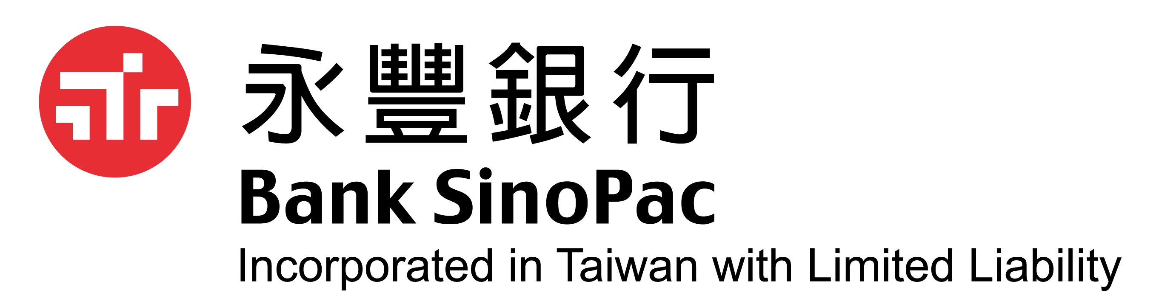 | 信用狀讓渡書 Letter of Assignment of Letter of Credit

To:永豐商業銀行 Bank SinoPac
立同意書人(以下稱本公司)願無條件且不可撤銷地將下述信用狀連同匯票和單據之一切權益及款項(以下稱「信
用狀應收帳款」)轉讓予貴行，並接受下列各項報價條件，且無需通知本公司或取得本公司之同意逕將此信用
狀應收帳款轉讓予任何第三人: We, the undersigned Beneficiary, hereby unconditionally and irrevocably assign to
you all our rights and benefits and proceeds with respect to the below letter of credit (L/C Receivables) and any drafts
and documents arising therefrom and agree to the terms and conditions in respect of the assignment of L/C
Receivables as provided below; and without notice to us or our further consent you may further assign the L/C
Receivables to any third party:
信用狀號碼 L/C No.
開狀銀行 Issuing Bank
保兌銀行 Confirming Bank
開狀日期 Issuing Date
信用狀到期日 Expiry Date
最後裝船日 Latest Shipment Date
貨品名稱 Goods
信用狀金額 L/C Amount
匯票金額 Draft Amount
匯票期間 Draft Tenor
買斷條件 Purchase Terms | 給付幣別 Payment Currency:
買斷條件 Purchase Terms | 貼現利率 Discount Interest Rate: | %
買斷條件 Purchase Terms | 代滙水佣金 Comm. In Lieu of Ex. | AT %
買斷條件 Purchase Terms | 託收手續費 Collection Fee: | AT
買斷條件 Purchase Terms | 郵遞費用 Courier Fee: | USD
買斷條件 Purchase Terms | 電報費 Cable Fee: | USD
買斷條件 Purchase Terms | 遲延息天數 Days of Grace Period:
買斷條件 Purchase Terms | 國外費用 Banking Charge : | USD
除信用狀規定之銀行費用外，另預扣 USD (如超過時，依實際金額補收)
Except for banking charges specified by the issuing bank, we agree a pre-deduction of
USD and reimburse the shortfall, if banking charges excess the amount.
本公司並同意以下條款 We also agree to be obliged by the following agreements:
1.本公司謹向貴行及貴行之受讓人聲明並保證，本公司就上開信用狀項下交易已履行所有應盡之義務。We represent and warrant to you and
your assignee(s) that we have fulfilled all our obligations under the aforementioned trade transaction(s).
2.本公司同意貴行對上開信用狀應收帳款權益之買斷係以貴行收到開狀銀行經核押相符之承兌電文為條件。We agree that you will purchase
the L/C receivables subject to your receipt of the acceptance advice by authenticated SWIFT from the Issuing bank.
3.本公司同意如因法院對開狀銀行下達禁止付款命令或因買賣雙方之商業糾紛，致使貴行或貴行之受讓人未能自開狀銀行收取應收帳款，本公司願意負責賠償貴行或貴行之受讓人因此所遭受之損失及費用，絕無異議。We agree that we shall be obligated to pay to you or your assignee(s) any sums not paid by the issuing bank due to court injunctions or commercial dispute(s) between the transaction parties that we are responsible for all losses and relevant expenses incurred by you or your assignee(s) without any objection.
4.本公司同意貴行之受讓人得直接向本公司請求上述之給付及費用，絕無異議。We agree without any objection that your assignee(s) may directly claim the above payment and expenses from us.
5.本公司同意貴行及貴行之受讓人皆非本公司之代理人或受委任人。We agree that neither you nor your assignee(s) are our agent or mandated.
6.本公司同意支付信用狀所產生之所有相關銀行費用及遲延息。 We agree to pay all banking charges specified by and related to the L/C, and interest incurred by late payment.
7.如本公司申請信用狀買斷給付幣別與信用狀所載幣別不同時，本公司接受以貴行所定匯率計算買斷金額及銷帳金額，並同意自行承擔銷帳當日因此產生之匯兌損益，包含開狀行支付金額不足償付時，本公司應補足不足部分予貴行。 If the payment currency applied by us for the purchase of L/C Receivables is not the currency denominated on the bill, we accept the exchange rate as your Bank may offer on the date of purchase / date of settlement and we undertake to endure the risk of exchange rate including to reimburse any shortfall pursuant to the fluctuations on settlement date.
8.本同意書以香港特別行政區法律為準據法，若發生任何爭議，香港特別行政區法院有非專屬管轄權。本讓渡書條款之中、英文解釋如有爭議，悉依英文為準。 We agree this Letter of Assignment of Letter of Credit shall be governed by and construed in accordance with the laws of Hong Kong Special Administrative Region of the P.R.C. and we irrevocably submit to the non-exclusive jurisdiction of the Hong Kong courts. The English version shall prevail in the case of disputes of the interpretation among Chinese and English version for the terms of the letter of assignment.
9. 請將買斷金額匯入以下帳戶 Please remit the purchase price into A/C No.: in USD.
核
印
立同意書人Beneficiary:
地址 Address:
電話 Phone Number: |  |  |  | _____________________________________________
 |  |  |  | (請蓋原留印鑑 Authorized Signature)
Ver.No. BSPHK -201111

